**175. Observables & You!**

* Speaker: That was a lot of talking about observables, but now we have an example of an observable and how it behaves under the hood .
* However, I know that this can look even more confusing, and you might ask yourself, well, when do I write this code? Because that's nice about the interval, but come on I don't need that interval that often in my application .
* And you would be right .
* And by the way, if you needed one you'd of course use the built-in interval function and not build your own one .
* So, what's the idea behind that example? The idea is that you understand what happens inside of an observable .

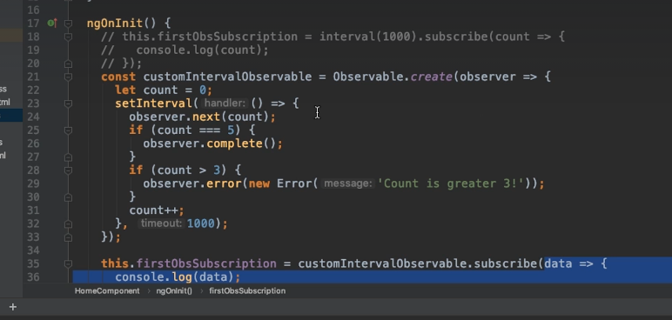

* Whenever you subscribe, and you set-up your different handler functions here, our xjs in the end merges them all together into one object and passes that object, the observer, to the observable .
* And inside of the observable, it will then interact with the observer, and let the observer know about new data and errors and so on .
* And that is how your functions get called .
* ***However, you rarely very, very very rarely build your own observables*** .
* More often, you use observables that come with libraries, like angular, like the route parents observable we already used under the hood .
* That in the end is a custom observable built by the angular team .
* But of course, you just use it like that .
* You rarely build your own ones, but still it's super important to understand how they work under the hood .
* And in the end, they all work a bit like that .
* They wrap some event source .
* In this case it's set interval .
* In our cases it could be an AJAX request, or a click listener or whatever it is, and they give you data, or possibly also errors, or the complete event .
* And you will mostly use subscribe and pass and functions that deal with that data or those errors .